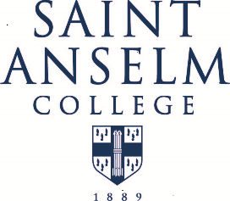
HEALTH SERVICES

NON-RESIDENT MEDICAL FACILITIES FEE
(OPTIONAL)

The medical facilities of the College Health Services are available not only to resident students, but also to those non-resident students who wish to take advantage of them for a fee of $100.00 per academic year or $50.00 per semester.

Please note that this fee is not mandatory.

Commuter students will need to pay an off-campus fee in order to receive non-emergency care at Health Services (This fee is considered part of Room and Board for Students living on campus). This is a yearly fee and entitles the student to all t he services provided by Health Services, including weekly clinics staffed by a physician or nurse practitioner, or registered nurse evaluation and assessment.

Please refer to Health Services web site for hour or operation.

If you choose to take this option, please complete the form below and return it to College Health Services with a check for $100.00 made payable to: Saint Anselm College.

- - - - - - - - - - - - - - - - - - - - - - - - - - - - - - - - - - - - - - - - - - - - - - - - - - - - - - - - - - - - - - - - - - -

NON-RESIDENT MEDICAL FACILITIES REGISTRATION

NAME

STUDENT ID NUMBER

I wish to take advantage of the medical facilities of the Saint Anselm College Health Services as a non-resident student and II enclose the fee of .

SIGNATURE

DATE

Please make check payable to:  SAINT ANSELM COLLEGE | Please return this form and check to:  COLLEGE HEALTH SERVICES  SAINT ANSELM COLLEGE - #1722  MANCHESTER, NH 03102-1310

